Isaac Bayon

Liri node application Homework due 11/7/2018

The following screenshots show the results of running commands for the liri node application Homework:

The application allows for 4 different programs to be used. The user must enter one of the following program names:

concert-this

spotify-this-song

movie-this

do-what-it-says

**No program selected**

If the user does not enter a program name, the application will display the message:

“You must select a program for this to work: concert-this, spotify-this-song, movie-this, or do-what-it-says”

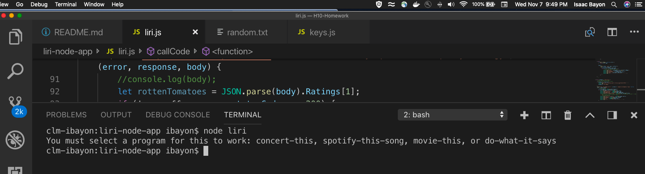

**concert-this**

with no search criteria (default response)

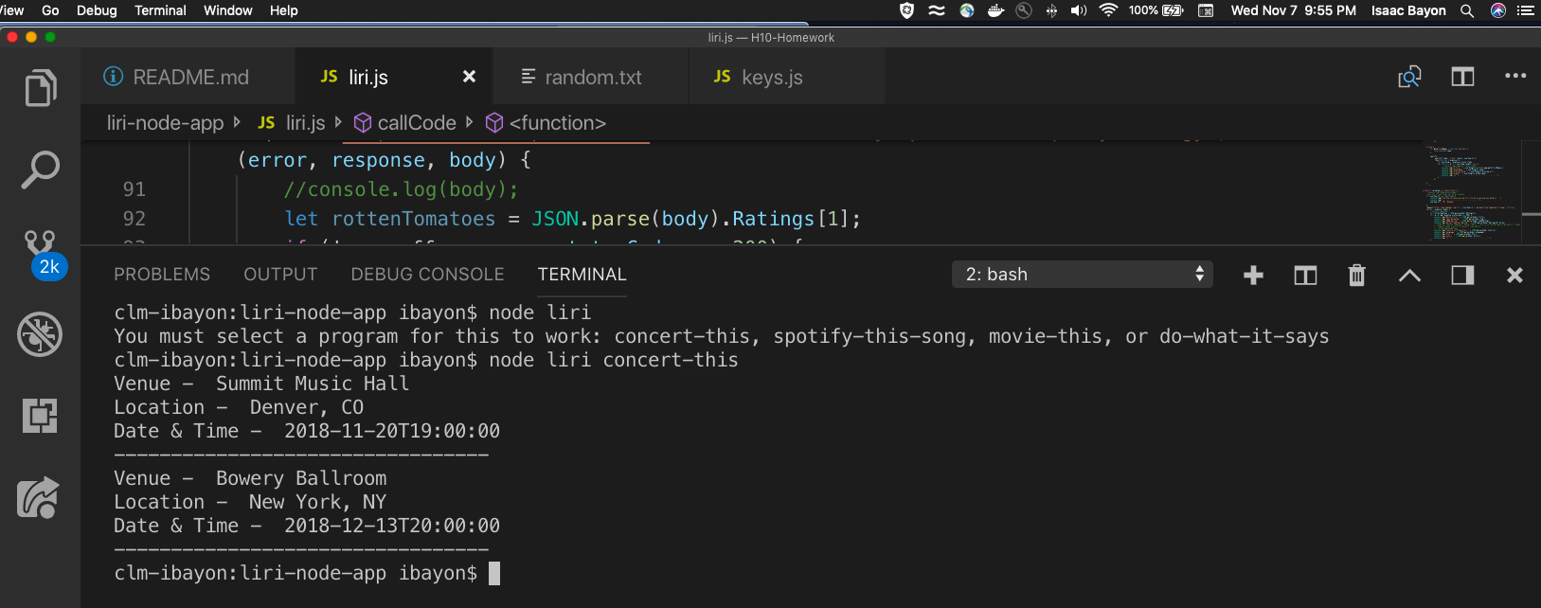

With a search criteria (user input = cher) 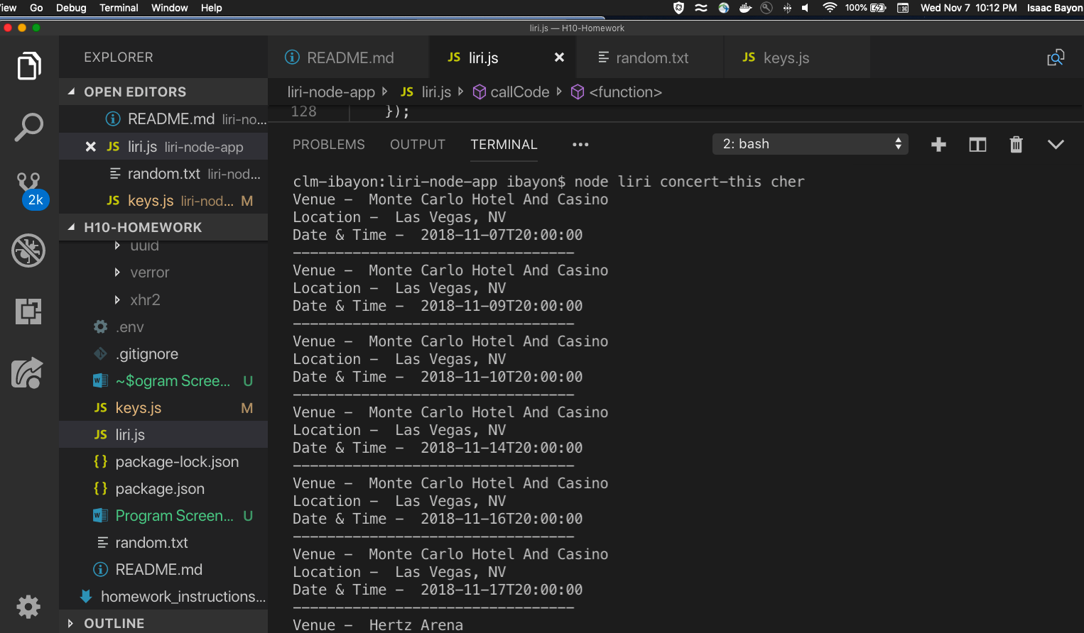

**spotify-this-song**

with no search criteria (default response)

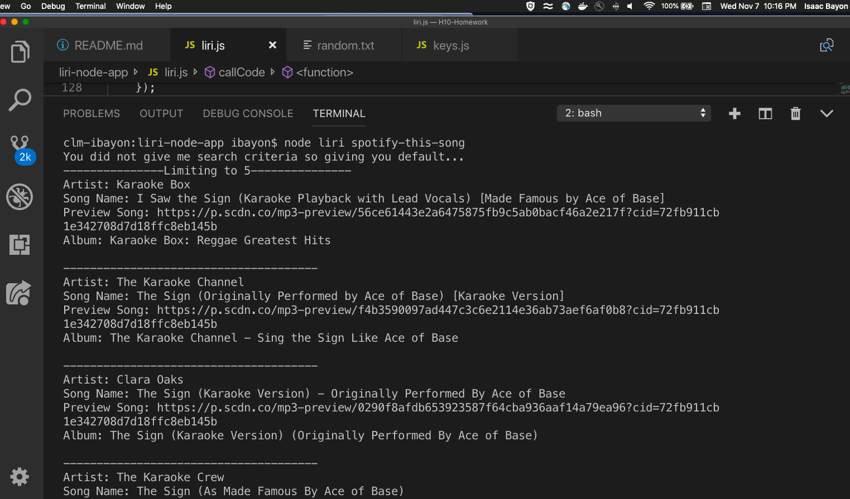

With a search criteria (user input = Ophelia)

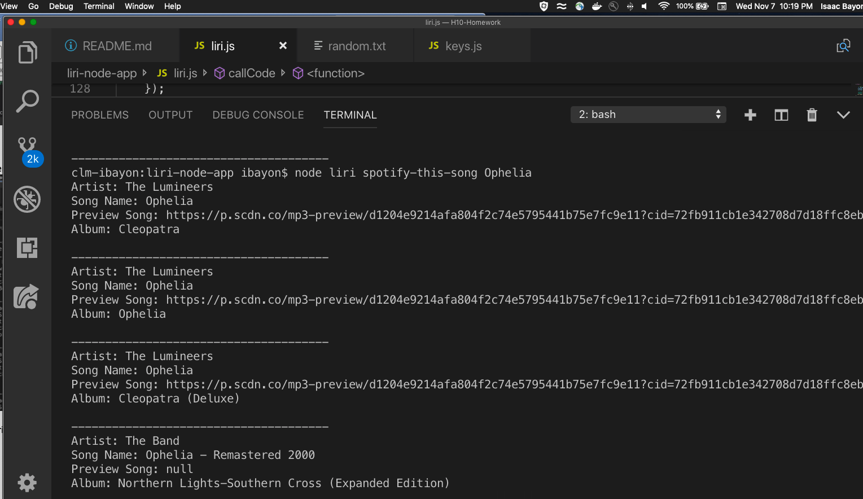

**movie-this**

with no search criteria (default response)

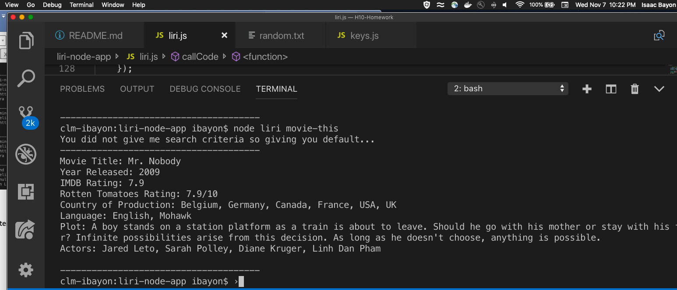

With a search criteria (user input = frozen)

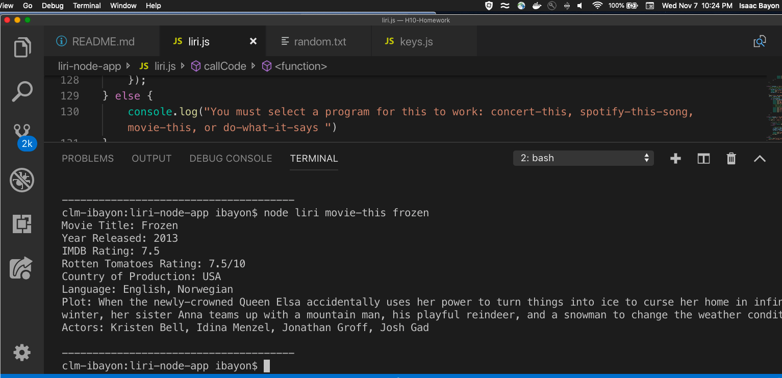

**do-what-it-says**

The text file currently has in it *spotify-this-song,"I Want it That Way"*. You can replace this with any of the other programs in this application and it will work:

*spotify-this-song,"I Want it That Way"*

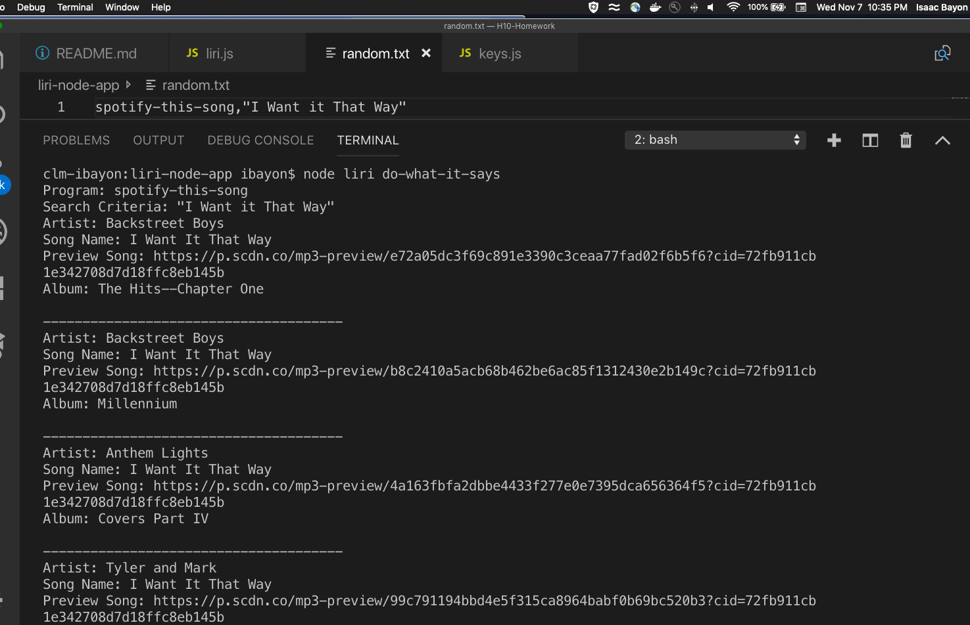

Or *concert-this,grande*

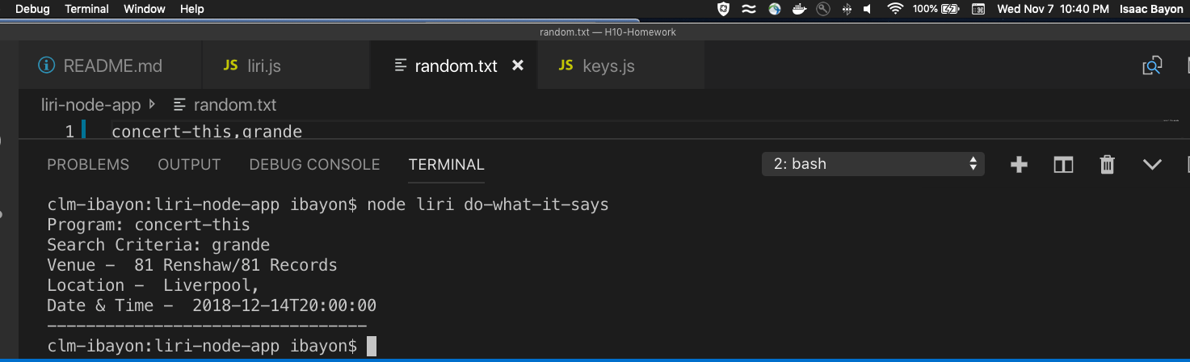

That’s it.